**Title:**

PROCEDURES TO CREATE A WORKSHEET IMPORTING DATA FROM DATABASE AND CALCULATE SUM OF ALL THE COLUMN

**Introduction:**

**1) MS Office:**

Microsoft Office, or simply Office, is a family of client software, server software, and services developed by Microsoft. It was first announced by Bill Gates on August 1, 1988, at COMDEX in Las Vegas. Initially a marketing term for an office suite (bundled set of productivity applications), the first version of Office contained Microsoft Word, Microsoft Excel, and Microsoft PowerPoint.

**2) MS Access:**

Microsoft Access is a database management system from Microsoft that combines the relational Microsoft Jet Database Engine with a graphical user interface and software-development tools. It is a member of the Microsoft Office suite of applications, included in the Professional and higher editions or sold separately.

**3) MS Excel:**

Microsoft Excel is a spreadsheet developed by Microsoft for Windows, macOS, Android and iOS. It features calculation, graphing tools, pivot tables, and a macro programming language called Visual Basic for Applications.

**ABSTRACT:** 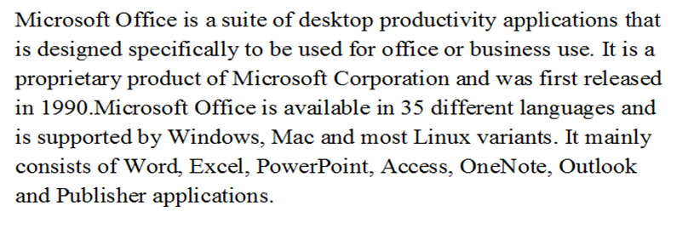

**OUTCOMES:**

By performing this practical we understood the importance of Database and Excel. We also got to know about AutoSum formula in Excel Spreadsheet and its use in Excel. It is used for Addition of Data.

**SOFTWARE RESOURSES:**

Computer System, Office Software Package

**APPLICATION:**

**1) MS Access:**

Microsoft Access Used in Business. Microsoft Access is a program that can be used for business. Microsoft Access Used in Schools. Microsoft Access Used in Office. Microsoft Access Used in The Workplaces. Microsoft Access Used for Programming Development.

**2) Excel:**

Import, export, and convert Excel, .csv, .txt and .ods formatted data. Use editing formula to perform calculations on your data and use formatting to create your own style. Chat in real time with others who are editing your spreadsheet while using the online version. Create charts with your data. Embed a spreadsheet — or individual sheets of your spreadsheet — on your blog or website.

**ORIGINAL OUTCOME:**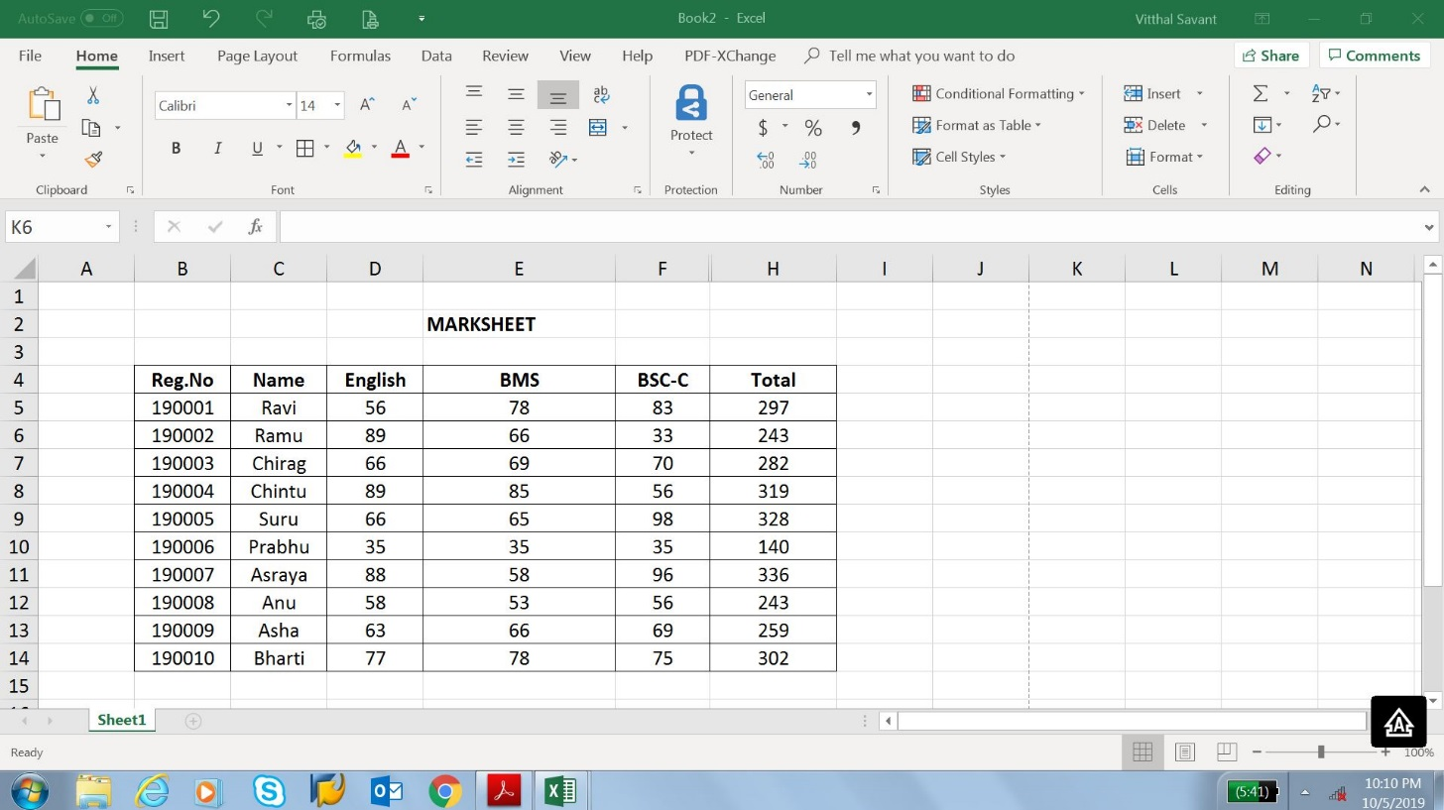

Fig No.1: Data Imported from MS access and after using AutoSum

Excel is a very flexible instrument to perform analyses and what-if scenario's. You use formulas in cells with one or more input cells to calculate the various situations. Spreadsheet alone do not satisfy all needs. Therefore, Access is used to pair with Excel.

**Conclusion:**